Lent Listening Groups
Resource for Churches

Plain Text Version

Contact:
Mirjam Ngoy-Verhage, Diocesan Discipleship Enabler
mirjam.ngoy@london.anglican.org
Websites:

www.lent2024.wayoflife.london
www.wayoflife.london

Content
01. Introduction page 3-5
02. The Liturgy page 6
03. Bible Passages page 7
04. Core Principles page 8
05. Week 1 – Online page 9
06. Week 2 – In context page 10-11
07. Week 3 – In context page 12-13
08. Week 4 – In context page 14-15
09. Week 5 – Online page 16
10. What’s Next? page 17

Appendix 1: page 18-24
Resources for Reflection
Appendix 2: page 25-31
Handouts for Individual Groups
(Week 2, 3 and 4)

Introduction
Overview
The offering
For Lent 2024, all across London Diocese are invited to a deep dive into the theme of listening as a tool for deepening discipleship. We will engage with a simple listening group practice that can be used by churches, small groups, or other friendship groups. Together we will explore how listening can help us share our journey of faith with each other and create space to pay attention to what God is doing in our lives. Surrounded by a small group of three to four people, we are encouraged to listen, notice, lean into discomfort, discern and respond.
Structure
This year’s offering will take place over five weeks and is a mix of online sessions hosted by our bishops, as well as small group sessions to work through in our own context using the materials provided:
Week 1: Online Session | Tuesday 20 February 2024, 7:30pm
Join in with the online session. You can join in individually, live-stream the session in your church or use the recording on a different day of the week.
Week 2, 3 and 4: In Context
Use this PDF resource to guide you through the listening group practice within your own context: in your church or as an individual listening group. This can be facilitated both in person or online at a time that is convenient for you and will take just over an hour each week.
Week 5: Online Session | Tuesday 19 March, 7:30pm
Join in with the online session. You can join in individually, live-stream the session in your church or use the recording on a different day of the week.

Background
Why listening groups?
Listening groups are a tool to help us share with others our experience of God in the midst of our lives. As we listen to each other prayerfully, we create space to grow and deepen our faith together. This has the potential to strengthen us in our relationship with God, ourselves and others.
Summary of the practice
After an opening prayer and time of reflection, we take turns to share; to talk about our recent experience of faith and to listen to each other in small groups of three to four people.
A listening group is not the same as a discussion group. The aim is not to fix each other’s problems or to give advice, but to sit with our questions and trust that God is with us in this process.
We are creating an atmosphere of prayerful listening, and we are recognising that great wisdom and learning may come from another in the group. By committing to meet in listening groups, we seek to strengthen our relationships as we:
- Encourage one another in paying attention to what God is doing in our lives;
- Develop the skills and habits of listening and sharing;
- Learn wisdom from one another’s experiences.
Progression
To begin with, the focus of our practice is primarily on silence and listening. The first listening exercise will be shaped around a Bible passage and ‘wonderings’, while the listening groups that follow will be kept more open in terms of what people share. As the group continues to journey together, more time for responses and reflections by group members can be built into the practice.
How to use this resource - Week 2, 3 and 4
This resource will give you an overview of the Lent Listening Groups offering and guide you through the Week 2, 3 and 4 listening group practice taking place in your own context. It is written with churches and larger groups of people in mind. The session will begin with the whole group meeting for an opening prayer, reflection and instructions. After this, people will break into small groups of three to four people for the listening group practice. Finally, groups will come back together for a joined time of reflection and prayer.
For people meeting as an individual group of three to four people, the handouts in Appendix 2 will lead you through Week 2, 3 and 4 of this offering.
Frequently Asked Questions
How do we form our listening groups?
As we are getting to grips with this new practice, it does not matter too much who we are in a group with. However, it will be important for people to feel safe enough to share in their group while being aware it will take some time to build trust.
Once people get more familiar with the practice, the make-up of the groups will play a more important role in taking this practice forward and making it sustainable.
Some people might prefer to be in a group with the same gender, while others might benefit from being with people who are in a similar season of life or working pattern, while others might enjoy journeying as part of an intergenerational group. There is not one right way of doing this and it may take some time to set up the right groups. It might be good to appoint someone in your church to help organise this process.
How much will I have to share with my group?
The aim of the practice is to help us share our journey of faith with others, but only to a level we feel comfortable with. We encourage group members to use discretion when sharing things of a personal or sensitive nature. We are allowed to pass when we are not sure what to share. As our group builds trust, we might feel encouraged to open up more.
How confidential will the sharing be?
We encourage groups to keep what has been shared within their group, unless someone in the group or anyone mentioned is felt to have a safeguarding risk. If you feel this is the case, please have a chat with your church leader or the parish safeguarding officer or contact the diocesan safeguarding team (safeguarding@london.anglican.org or call 020 7932 1224).
Can people just come to one or two sessions?
Each week builds on what has been practised the week before, so a level of commitment from people is important to make the most of this offering.
What should we do if a group is struggling?
Our advice would be to stick to at least three sessions, as it will take some time to get used to the practice and build trust. However, there is nothing wrong with reshaping groups slightly if things aren’t working out for practical or other reasons. It might take a reshuffle for everyone to find a group that is right for them.
Can listening groups be larger than four people?
While the practice will still work with larger groups, we recommend a group size of three to four people, to allow for deeper sharing without it taking too much time.

The Liturgy
Opening Liturgy
Candle
We light a candle as a sign of God’s presence with us.
Breath prayer
Be still (inhale)
and know that I am God. (exhale)
Opening prayer
Jesus Christ,
as we meet in your name:
speak Lord, we are listening.
As we pause and pray:
speak Lord, we are listening.
As we share and savour:
speak Lord, we are listening.
As we spend time together in your presence:
may we meet you
in the world around us, in one another,
and in our own hearts.
Amen.
Closing Liturgy
Breath prayer
Be still (inhale)
and know that I am God. (exhale)
Closing prayer
Jesus Christ,
we met in your name,
pausing and praying,
sharing and savouring,
listening and learning .
We thank you for meeting us:
in our hearts, in one another,
and in the world around us.
As we journey together,
help us to be still
and know that you are God. Amen.
Blessing
May the strength of God sustain us;
may the power of God preserve us;
may the hands of God protect us;
may the way of God direct us;
may the love of God go with us
this night and forever.
Amen.
We blow out our candle.
Bible Passages
WEEK 1 & 2 | Mark 1:9-15 (NRSV)
In those days Jesus came from Nazareth of Galilee and was baptised by John in the Jordan. And just as he was coming up out of the water, he saw the heavens torn apart and the Spirit descending like a dove on him. And a voice came from heaven,
‘You are my Son, the Beloved; with you I am well pleased.’ And the Spirit immediately drove him out into the wilderness. He was in the wilderness for forty days, tempted by Satan; and he was with the wild beasts; and the angels waited on him. Now after John was arrested, Jesus came to Galilee, proclaiming the good news of God, and saying, ‘The time is fulfilled, and the kingdom of God has come near; repent, and believe in the good news.
WEEK 3 | Mark 4:35-41 (NRSV)
On that day, when evening had come, he said to them, ‘Let us go across to the other side.’ And leaving the crowd behind, they took him with them in the boat, just as he was. Other boats were with him. A great gale arose, and the waves beat into the boat, so that the boat was already being swamped. But he was in the stern, asleep on the cushion; and they woke him up and said to him, ‘Teacher, do you not care that we are perishing?’ He woke up and rebuked the wind, and said to the sea, ‘Peace! Be still!’ Then the wind ceased, and there was a dead calm. He said to them, ‘Why are you afraid? Have you still no faith?’ And they were filled with great awe and said to one another, ‘Who then is this, that even the wind and the sea obey him?’
WEEK 4 & 5 | Mark 8:27-33 (NRSV)
Jesus went on with his disciples to the villages of Caesarea Philippi; and on the way he asked his disciples, ‘Who do people say that I am?’ And they answered him, ‘John the Baptist; and others, Elijah; and still others, one of the prophets.’ He asked them, ‘But who do you say that I am?’ Peter answered him, ‘You are the Messiah.’ And he sternly ordered them not to tell anyone about him.
Then he began to teach them that the Son of Man must undergo great suffering, and be rejected by the elders, the chief priests, and the scribes, and be killed, and after three days rise again. He said all this quite openly. And Peter took him aside and began to rebuke him. But turning and looking at his disciples, he rebuked Peter and said, ‘Get behind me, Satan! For you are setting your mind not on divine things but on human things.’
Core Principles
As we listen to each other, we are invited to adopt postures of:

Sharing
We are invited to share about our experience of God in the midst of life’s circumstances. We do not need to present a ‘perfect’ faith, but are invited to keep it real and be open about when we feel close to God as well as when God seems absent.
Savouring
We might be tempted to go into our usual conversation mode: waiting for our turn to speak or comment. However, this practice is different from our usual discussing or sharing of knowledge. For our prayerful listening to flourish, we need to hold back. We do not interrupt each other but create space to really savour and sit with what has been shared. This will involve moments of silence. Our act of listening to each other becomes a form of prayer in itself.
Support
We meet together not to fix each other’s problems. We consciously stay away from judgement or giving each other advice. We have courage to sit with the questions and trust that God is with us in this process. In creating an environment of love and support, we want to mirror an image of our God welcoming us with open arms.

Commitment
We will do our best to make our sessions a priority and will let others know if for any reason we are unable to attend.
Confidentiality
We use discretion when sharing things of a personal or sensitive nature. What has been shared stays in the group, unless otherwise agreed or someone in the group or anyone mentioned is felt to have a safeguarding risk. If you feel this is the case,
please have a chat with your church leader, the parish safeguarding officer or contact the diocesan safeguarding team (safeguarding@london.anglican.org / 02079321224).

Week 1 – Online

Overview

Communal launch of our Lent Listening Groups
With Bishop Lusa, the Revd Richard Carter and Mirjam Ngoy-Verhage

Timetable
Welcome and Introduction 7:30-7:35
Opening Liturgy 7:35-7:40
Reflection: Listening Groups - a Biblical framework 7:40-7:55
Conversation 7:55-8:05
Modelling a Listening Group session 8:05-8:20
What will the next four weeks look like? 8:20-8:30
Q&A 8:30-8:40
Closing Liturgy 8:40-8:45

Please note this is a provisional timetable which might be subject to change.

What you need
All participants need access to a copy of ‘The Liturgy’, ‘Bible Passages’ and ‘Core Principles’ (page 6-8). It will also be helpful to have copies of the Artwork ‘The Baptism of Christ’ (page 22) available.
As part of our Opening Liturgy, we will light a candle together. If you are able, please have a candle and a lighter at hand.

How to access this session
Zoom access details have been sent out as part of your registration and will be sent out again a week before this meeting.
For access to the video recording of this session, visit www.lent2024.wayoflife.london (available from 6pm the day after our live session).

Week 2 – In Context

Introduction for Session Leaders
This week we will have a first go at our listening group practice, shaping our sharing around a Bible passage. Decide on a suitable time to meet during the week, whether online or in person. You will need just over an hour to work through this session.
This outline is written for churches meeting as a bigger group: opening and closing the session together but splitting up into smaller groups of three to four people for the listening group practice. (Handouts for individual listening groups can be found in Appendix 2.)

What you need
For each participant, you will need a copy of ‘The Liturgy’, ‘Bible Readings’ and ‘Core Principles’ (page 6-8), and the ‘Week 2 Handout’ (page 10). You will also need a candle and a lighter.

Structure of the session
- Open in prayer using the ‘Opening Liturgy’. (3 min)
- Use today’s Bible passage or one of the resources in Appendix 1 to lead a short time of reflection. This involves holding a moment of silence and slowly reading a Bible passage, poem or quote. You could also sit with one of the artworks or play a reflective piece of music. The aim is to help people get into a posture of silence and attentiveness to God, each other and themselves. (7 min)
- Read through the ‘Core Principles’, and the ‘Week 2 Handout’, making sure everyone agrees and understands today’s listening group practice. (10-15 min)
- Split into groups of three to four people to work through the listening group practice. (30-40 min)
- Gather back together and spend some time reflecting on the practice:
What was it like to share without being interrupted?
What did it feel like being listened to?
Were there any distractions that made it difficult to keep listening to others? (8 min)
What was it like to share something without being interrupted?
- Conclude the session using the ‘Closing Liturgy’. (2 min)

Week 2 – Handout

Listening Group Practice
1. Hold (2 min)
Appoint someone to facilitate the practice and ‘hold the space’ this week. This involves keeping an eye on the time and reminding the group of the core principles when necessary. (You will take turns to do this going forward.)
2. Check in (8 min)
Take turns introducing yourselves to each other. Share anything that is on your mind right now which might prevent you from being fully present. These might be questions around the process or anything going on in your life that you would like to park for a while.
3. Share (20-30 min)
Bible passage: Choose one of you to slowly reads this week’s Bible passage to the group (Mark 1:9-15). Get someone else to read it for a second time. After this second reading, each person in the group is invited to share one word or a short sentence from the passage that speaks to them without offering an explanation. Choose someone to read the passage a third time. Then each person is invited to share a few words, no more than one minute, on why or how that verse speaks to them personally. Hold half a minute of silence between each sharing.
Wonderings: Choose one of you to read out each one of the ‘wonderings’ below. Then take turns to briefly reflect on one of the ‘wonderings’ of your choice about yourself. Hold half a minute of silence between each person sharing. If there is any time left, go round the group again; each person reflecting on a different wondering.
Wonderings
I wonder if you have had moments in the past month when you’ve had a sense of God speaking to you.
I wonder what it means for you to realise you are also the Beloved of God.
I wonder whether any times of wilderness in your life have become experiences of revelation.
I wonder what the ‘good news’ is for you today.
4. Reflect (10 min)
Use the following questions to reflect on the practice together (don’t worry if you have run out of time as you will also do this as part of the bigger group):
- What was it like to share something without being interrupted?
- What did it feel like being listened to?
- Were there any distractions that made it difficult to keep listening to others?

This listening exercise was inspired by the Nazareth Community sharing practice as developed by the Revd Richard Carter.
Week 3 – In Context
Introduction for Session Leaders
While last week’s sharing was shaped around a Bible passage, this week we will be a having a first go at sharing more generally about our journey of faith. Decide on a suitable time to meet during the week, whether online or in person. You will need just over an hour to work through this session.
This outline is written for churches meeting as a bigger group: opening and closing the session together but splitting up into smaller groups of three to four people for the listening group practice. (Handouts for individual listening groups can be found in Appendix 2.)
What you need
For each participant, you will need a copy of ‘The Liturgy’, ‘Bible Passages’ and ‘Core Principles’ (page 6-8), and the ‘Week 3 Handout’ (page 12). You will also need a candle and a lighter.
Structure of the session
- Open in prayer using the ‘Opening Liturgy’. (3 min)
- Use today’s Bible passage or one of the resources in Appendix 1 to lead a short time of reflection. This involves holding a moment of silence and slowly reading a Bible passage, poem or quote. You could also sit with one of the artworks or play a reflective piece of music. The aim is to help people get into a posture of silence and attentiveness to God, each other and themselves. (7 min)
- Read through the ‘Core Principles’, and the ‘Week 3 Handout’, making sure everyone agrees and understands today’s listening group practice. (10-15 min)
- Split into groups of three to four people to work through the listening group practice. (30-40 min)
- Gather back together and spend some time reflecting on the practice:
What was it like to share without being interrupted?
What did it feel like being listened to?
Were there any distractions that made it difficult to keep listening to others?
Was the experience any different from last week? (8 min)
- Conclude the session using the ‘Closing Liturgy’. (2 min)

Week 3 – Handout

Listening Group Practice
1. Hold (2 min)
Appoint a group member to facilitate the practice and ‘hold the space’ this week, ideally someone else from last week. This person will keep an eye on the time and remind the group of the core principles when necessary.
2. Check in (8 min)
Share anything that is on your mind right now which might prevent you from being fully present. These might be questions around the process or anything that happened today that you would like to park for a while.
3. Share (20-30 min)
PART 1 | Bible passage:
Choose one of you to slowly reads this week’s Bible passage to the group (Mark 4:35-41). Take turns to share for one to two minutes each reflecting on the following question:
In what way is this Bible passage speaking to me and my life right now?
The person sharing should not be interrupted. After one minute has passed, the facilitator might give the person sharing a gentle nudge. Hold half a minute of silence between each person sharing.
PART 2 | Faith journey:
Choose one of you to read out each one of the ‘wonderings’ below. Take turns to reflect on one of the ‘wonderings’ of your choice, about yourself, for three to four minutes each. Hold half a minute of silence between each person sharing.
Wonderings
I wonder how Christ has been present for you in the past week.
I wonder if Christ has also been present in your struggles.
I wonder what has helped you to listen to God and what have been distractions.
I wonder what help you seek from God at this point in your life.
4. Reflect (10 min)
Use the following questions to reflect on the practice together (don’t worry if you have run out of time as you will also do this as part of the bigger group):
- What was it like to share something without being interrupted?
- What did it feel like being listened to?
- Were there any distractions that made it difficult to keep listening to others?
- Was the experience any different from last week?

Week 4 – In Context
Introduction for Session Leaders
For this final lent listening group practice, we will start to build in some responses to people’s sharing.
Decide on a suitable time to meet during the week, whether online or in person. You will need just over an hour to work through this session.
This outline is written for churches meeting as a bigger group: opening and closing the session together but splitting up into smaller groups of three to four people for the listening group practice. (Handouts for individual listening groups can be found in Appendix 2.)
What you need
For each participant, you will need a copy of ‘The Liturgy’, ‘Bible Passages’ and ‘Core Principles’ (page 6-8), and the ‘Week 4 Handout’ (page 14). You will also need a candle and a lighter.
Structure of the session
- Open in prayer using the ‘Opening Liturgy’. (3 min)
- Use today’s Bible passage or one of the resources in Appendix 1 to lead a short time of reflection. This involves holding a moment of silence and slowly reading a Bible passage, poem or quote. You could also sit with one of the artworks or play a reflective piece of music. The aim is to help people get into a posture of silence and attentiveness to God, each other and themselves. (7 min)
- Read through the ‘Core Principles’, and the ‘Week 4 Handout’, making sure everyone agrees and understands today’s listening group practice. (10 min)
- Split into groups of three to four people to work through the listening group practice. (30-45 min)
- Gather back into one group and spend some time reflecting on the practice: What was it like to add in some responses this session?
What was it like to get reflected back a word or sentence of your own sharing?
How might continuing this practice help you in your journey of discipleship? (8 min)
- Conclude the session using the ‘Closing Liturgy’. (2 min)

Week 4 – Handout

Listening Group Practice
1. Hold (2 min)
Appoint someone to facilitate the practice and ‘hold the space’. This involves keeping an eye on the time and reminding the group of the core principles when necessary.
2. Check in (8 min)
Share anything that is on your mind right now which might prevent you from being fully present. These might be questions around the process or anything that happened today that you would like to park for a while.
3. Share (30 min)
PART 1 | Bible passage:
Choose one of you to slowly reads this week’s Bible passage to the group (Mark 8:27-33). Take turns to share for one to two minutes each reflecting on the following question: In what way is this Bible passage speaking to me and my life right now?
The person sharing should not be interrupted. After one minute has passed, the facilitator might give the person sharing a gentle nudge. Hold half a minute of silence between each person sharing.
PART 2 | Faith journey:
Share: Choose one of you to read out each one of the ‘wonderings’ below. Take turns to reflect on one of the ‘wonderings’ of your choice, about yourself, for three to four minutes each. When you finish sharing, the facilitator will gently invite people into half a minute of silence.
Respond: After a person has shared, the facilitator will invite those who have listened to reflect back one word or sentence that stood out to them while listening. The invitation is to stick with the language that was used by the person sharing rather than interpreting or using your own words. It is like holding up a mirror: repeating the words back exactly as they have been shared. You might reflect back the whole sentence, or you might select a few words – or even one single word – from what was said.
If someone does not have a particular response to share, they can pass. When everyone has had a chance to share their response, the person who shared their story might want to shortly reflect on what was offered.
Repeat the same process for each person sharing.
Wonderings
I wonder how Christ has been present for you in the past week.
I wonder if Christ has also been present in your struggles.
I wonder what has helped you to listen to God and what have been distractions.
I wonder what help you seek from God at this point in your life.
4. Reflect (5 min)
If you have any time left, spend some time reflecting on the exercise and what you will take away.
Week 5 – Online

Overview

Communal reflection on our Lent Listening Groups
With Bishop Sarah, Bishop Emma, Mirjam Ngoy-Verhage and others

Timetable
Welcome and Introduction 7:30-7:35
Opening Liturgy 7:35-7:40
Modelling of a Listening Group session 7:40-8:00
Community Examen to reflect on Lent Listening Groups 8:00-8:10
Conversation and sharing of experiences 8:10-8:30
How might we continue listening groups after Lent? 8:30-8:40
Closing Liturgy 8:40-8:45
Please note this is a provisional timetable which might be subject to change.

What you need
All participants need access to a copy of ‘The Liturgy’ and ‘Bible Passages’ (page 6-7). As part of our Opening Liturgy, we will light a candle together. If you are able, please have a candle and a lighter at hand.

How to access this session
Zoom access details have been sent out as part of your registration and will be sent out again a week before this meeting.
For access to the video recording of this session, visit www.lent2024.wayoflife.london (available from 6pm the day after our live session).

What’s Next

Looking Forward
We very much hope that you enjoyed our deep dive into listening groups and feel inspired to continue this practice after Lent. A good meeting pattern for listening groups would be once every four to six weeks. Meetings could take place either in person or online. Depending on group size, a listening group session would usually take around an hour.
As a church, you could continue to run groups jointly. Several groups will come together, maybe at a set time each month, for a shared opening prayer and reflection, before going into smaller groups of three to four people for a time of sharing. Groups can also run individually, with members organising their own pattern of meeting to fit around other commitments and life patterns. A review could be scheduled after six to twelve months.

What you need
For your next few meetings, we suggest a repeat of Week 4’s session, using a different Bible passage each time you meet (for instance using the Lectionary). As groups become more established and build trust, they will rely less on the outline and wonderings and might build in more time for gentle responses to what has been shared. We ask ourselves: what do we notice, sense, feel or wonder as we sit before this person with the knowledge that God is present in this moment too? This could lead into a time of prayer for each other, remembering once more that we are not gathered to fix each other’s problems, but to hold each other in the presence of God. At all times, the listening aspect of our practice remains at the heart of our time of sharing.

Get in touch
We would love to hear about your experience of this practice and if and how you plan to continue with it in the future. Please do reach out to mirjam.ngoy@london.anglican.org. You can use the same address to find out more about our Way of Life resources and Communal Practice Toolkit for churches, or visit www.wayoflife.london.
There is also a feedback form available here: https://us21.list-manage.com/survey?u=e9128e00cfdd0abe87054e78d&id=81a81e10ed&attribution=false

Appendix 1
Resources for Reflection

ART 1

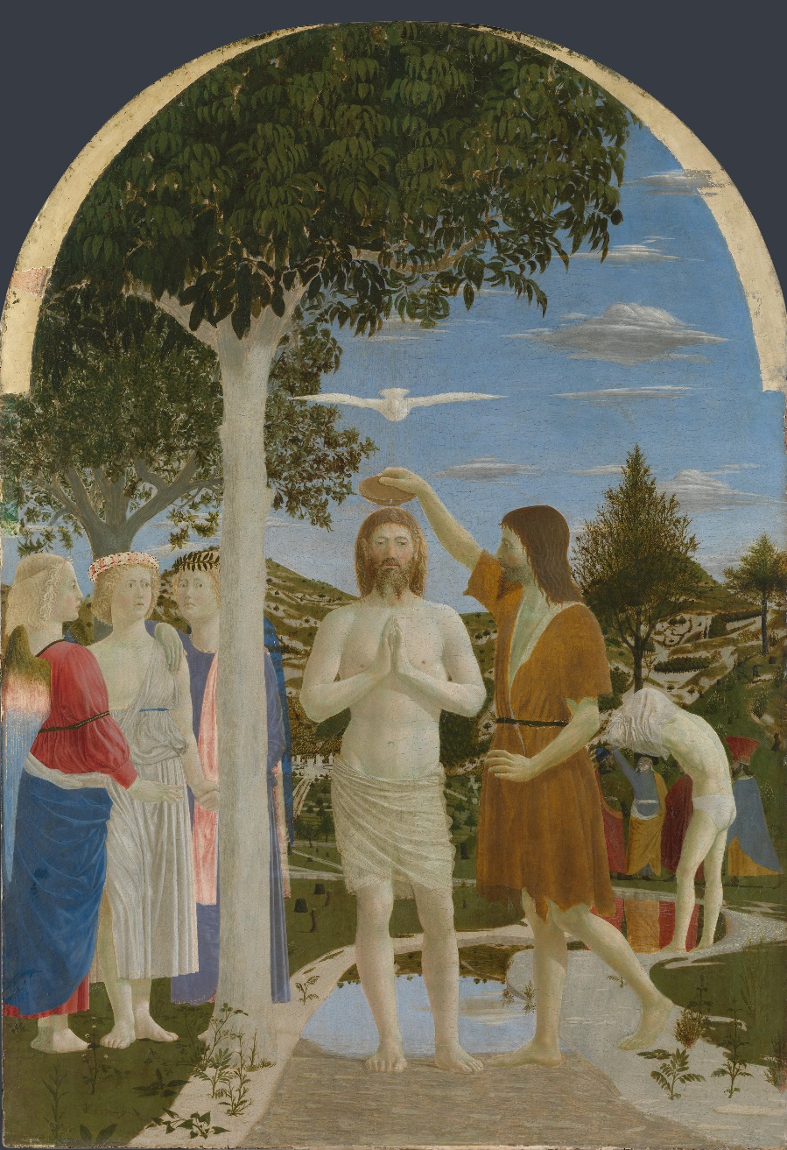

The Baptism of Christ
Creator: Piero della Francesca | © The National Gallery, London

Image Description:
Christ stands in a shallow, winding stream as John the Baptist pours a small bowl of water over his head. Three angels in colourful robes witness the event.
At this very moment the voice of God was heard – ‘This is my Son, whom I love; with him I am well pleased’ (Matthew 3: 16) – and the Holy Ghost, shown here as a dove flying over Christ’s head and towards us, descended upon him.
This painting was made for the small chapel dedicated to Saint John the Baptist in the Camaldolese abbey of Piero’s hometown, Borgo Sansepolcro.

ART 2

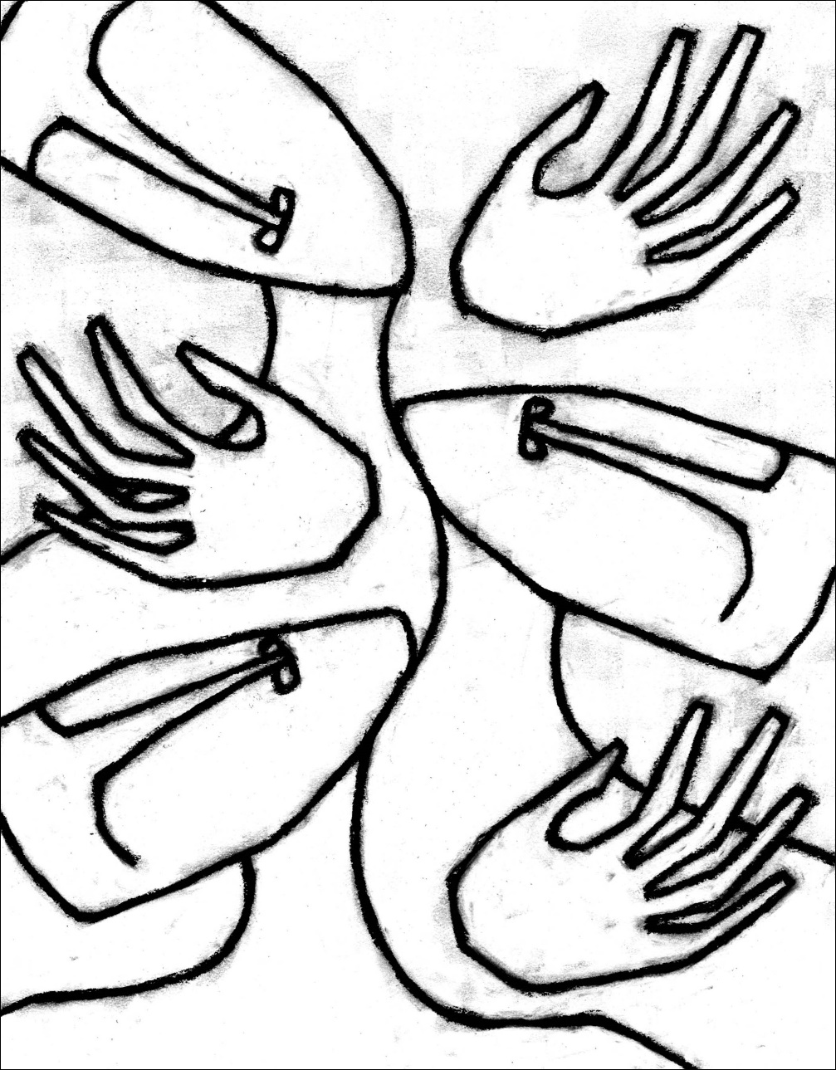

Listening
Jan Richardson
Image Description:
A black and white drawing of three hands and three faces with a black outline. The hands are shown in an open position, reaching out. The faces are tilted towards each other. The lines used to create the hands and faces are thick and bold, giving them a strong presence on the page. The background of the image is completely white, allowing for maximum contrast between the dark lines of the hands and faces and the blank space around them.

ART 3

Wakens My Ear To Listen
Jan Richardson
Image Description:
Abstract painting. The dominant colours in the foreground are blue and black, with accents of dark grey and gold. Different textures of paintbrush strokes are visible.

POEMS AND QUOTES

When Someone Deeply Listens To You
When someone deeply listens to you
it is like holding out a dented cup
you’ve had since childhood
and watching it fill up with
cold, fresh water.
When it balances on top of the brim,
you are understood.
When it overflows
and touches your skin,
you are loved.
When someone deeply listens to you
the room where you stay
starts a new life
and the place where you wrote
your first poem
begins to glow in your mind’s eye.
It is as if gold has been discovered!
When someone deeply listens to you
your bare feet are on the earth
and a beloved land that seemed distant
is now at home within you.
John Fox

Blessing to Open the Ear
That as we wake
we will listen.
That as we rise
we will listen.
That before our first words
of the day
we will listen.
That when we meet
we will listen.
That at noontime
we will listen.
That at dusk
we will listen.
That at the gathering
of night
we will listen.
That entering sleep
we will listen still.
Jan Richardson
https://paintedprayerbook.com/2012/03/27/day-31-wakens-my-ear-to-listen/

Sacred Silence
God’s sacred silence is not the absence of language but the fullness of presence. It forms us in a posture of listening, seeing, and being with one another before trying to define one another. It is a universal language shared by all people and all creation. To discover where our diverse cultural and spiritual traditions meet, we begin with this common language. From a shared silence, we discover our common prayer; even through language barriers, we share common needs, emotions, and desires.
Cindy S. Lee, Our Unforming:
De-Westernizing Spiritual Formation

Listening as Spiritual Hospitality
To listen is very hard, because it asks of us so much interior stability that we no longer need to prove ourselves by speeches, arguments, statements, or declarations. True listeners no longer have an inner need to make their presence known. They are free to receive, to welcome, to accept.
Listening is much more than allowing another to talk while waiting for a chance to respond. Listening is paying full attention to others and welcoming them into our very beings. The beauty of listening is that, those who are listened to start feeling accepted, start taking their words more seriously and discovering their own true selves.
Listening is a form of spiritual hospitality by which you invite strangers to become friends, to get to know their inner selves more fully, and even to dare to be silent with you.
Henri Nouwen
https://henrinouwen.org/meditations/listening-spiritual-hospitality/

On Listening: Advice to Christians
The first service that one owes to others in the fellowship consists in listening to them. Just as love to God begins with listening to His Word, so the beginning of love for the brethren is learning to listen to them. It is God’s love for us that He not only gives us His Word but also lends us His ear.
So it is His work that we do for our brother when we learn to listen to him. Christians, especially ministers, so often think they must always contribute something when they are in the company of others, that this is the one service they have to render. They forget that listening can be a greater service than speaking.
Many people are looking for an ear that will listen. They do not find it among Christians, because these Christians are talking where they should be listening. But he who can no longer listen to his brother will soon be no longer listening to God either; he will be doing nothing but prattle in the presence of God too.
This is the beginning of the death of the spiritual life, and in the end there is nothing left but spiritual chatter and clerical condescension arrayed in pious words...
Dietrich Bonhoeffer, Life Together

Sound of the Genuine
The sound of the genuine is flowing through you. Don’t be deceived and thrown off by all the noises that are part even of your dreams and your ambitions when you don’t hear the sound of the genuine in you. Because that is the only true guide you will ever have and if you don’t have that you don’t have a thing... Cultivate the discipline of listening to the sound of the genuine in yourself.
There is something in everybody that waits and listens for the sound of the genuine in other people... I must wait and listen for the sound of the genuine in you. I must wait. For if I cannot hear it, then in my scheme of things, you are not ever present. So as I live my life then, this is what I am trying to fulfill... that I’m secure because I hear the sound of the genuine in myself, and having learned to listen to that, I can become quiet enough, still enough to hear the sound of the genuine in you.
Howard Thurman, from Baccalaureate address at Spelman College in 1980.

Appendix 2
Week 2, 3 and 4 Handouts
for Individual Groups

Week 2 – Handout

Outline for Individual Groups (3-4 people)
You will need: a candle, lighter, Bible, copy of this handout, copy of the ‘Core Principles’ (page 8) and access to Appendix 1.
1. Prepare (5 min)
Read through the ‘Core Principles’ and this ‘Week 2 Handout’, making sure all understand and are comfortable with the process.
2. Hold (2 min)
Appoint someone to facilitate the practice and ‘hold the space’ this week. (You will take turns going forward.) This involves reading the reflection (step 5), keeping an eye on the time and reminding the group of the core principles when necessary.
3. Check in (8 min)
Take turns to share anything that is on your mind right now that will help you be more present. These might be questions around the process or anything that happened today that you would like to park for a while.
4. Opening prayer (3 min)
Light a candle as a sign of God’s presence. Stay in silence for a moment. Then say together: Creator God, as we spend time together in your presence: may we meet you in the world around us, in one another, and in our own hearts. Amen.
5. Settle (5-10 min)
The facilitator will lead a short time of reflection to help the group get into a posture of silence and attentiveness: Hold two minutes of silence. Slowly read this week’s Bible passage or one of the quotes or poems from Appendix 1 (or use your own quote, piece of music, artwork, etc.). Follow this with another minute of silence.
6. Share (20-30 min)
Bible passage: Choose one of you to slowly reads this week’s Bible passage to the group (Mark 1:9-15). Get someone else to read it for a second time. After this second reading, each person in the group is invited to share one word or a short sentence from the passage that speaks to them without offering an explanation. Choose someone to read the passage a third time. Then each person is invited to share a few words, no more than one minute, on why or how that verse speaks to them personally. Hold half a minute of silence between each sharing.
Wonderings: Choose one of you to read out each one of the ‘wonderings’ below. Then take turns to briefly reflect on one of the ‘wonderings’ of your choice about yourself. Hold half a minute of silence between each person sharing. If there is any time left, go round the group again; each person reflecting on a different wondering.
Wonderings
I wonder if you have had moments in the past month when you’ve had a sense of God speaking to you.
I wonder what it means for you to realise you are also the Beloved of God.
I wonder whether any times of wilderness in your life have become experiences of revelation.
I wonder what the ‘good news’ is for you today.
7. Reflect (5-10 min)
Spend some time reflecting on the practice:
- What was it like to share without being interrupted?
- What did it feel like being listened to?
- Were there any distractions that made it difficult to keep listening to others?
8. Closing prayer (2 min)
Pray the following words together before blowing out the candle:
Jesus Christ, we thank you for meeting us: in our hearts, in one another, and in the world around us. As we journey together, help us to be still and know that you are God. Amen.

Week 3 – Handout

Outline for Individual Groups (3-4 people)
You will need: a candle, lighter, Bible, copy of this handout, copy of the ‘Core Principles’ (page 8) and access to Appendix 1.
1. Prepare (5 min)
Read through the ‘Core Principles’ and this ‘Week 3 Handout’, making sure all understand and are comfortable with the process.
2. Hold (2 min)
Appoint someone to facilitate today’s practice and to ‘hold the space’. This involves leading the reflection (step 5), keeping an eye on the time and reminding the group of the core principles when necessary.
3. Check in (8 min)
Take turns to share anything that is on your mind right now that will help you be more present. These might be questions around the process or anything that happened today that you would like to park for a while.
4. Opening prayer (3 min)
Light a candle as a sign of God’s presence. Stay in silence for a moment. Then say together: Creator God, as we spend time together in your presence: may we meet you in the world around us, in one another, and in our own hearts. Amen.
5. Settle (5-10 min)
The facilitator will lead a short time of reflection to help the group get into a posture of silence and attentiveness: Hold two minutes of silence. Slowly read this week’s Bible passage or one of the quotes or poems from Appendix 1 (or use your own quote, piece of music, artwork, etc.). Follow this with another minute of silence.
6. Share (20-30 min)
PART 1 | Bible passage: Choose one of you to slowly reads this week’s Bible passage to the group (Mark 4:35-41). Take turns to share for one to two minutes each reflecting on the following question:
In what way is this Bible passage speaking to me and my life right now?
The person sharing should not be interrupted. After one minute has passed, the facilitator might give the person sharing a gentle nudge. Hold half a minute of silence between each person sharing.
PART 2 | Faith journey: Choose one of you to read out each one of the wonderings below. Take turns to reflect on one of the wonderings of your choice, about yourself, for three to four minutes each. Hold half a minute of silence between each person sharing.
Wonderings
I wonder how Christ has been present for you in the past week.
I wonder if Christ has also been present in your struggles.
I wonder what has helped you to listen to God and what have been distractions.
I wonder what help you seek from God at this point in your life.
7. Reflect (5-10 min)
Spend some time reflecting on the practice:
- What was it like to share without being interrupted?
- What did it feel like being listened to?
- Were there any distractions that made it difficult to keep listening to others?
8. Closing prayer (2 min)
Pray the following words together before blowing out the candle:
Jesus Christ, we thank you for meeting us: in our hearts, in one another, and in the world around us. As we journey together, help us to be still and know that you are God. Amen.

Week 4 – Handout

Outline for Individual Groups (3-4 people)

You will need: a candle, lighter, Bible, copy of this handout, and access to Appendix 1.
1. Prepare (5 min)
Read through this handout together, making sure all understand and are comfortable with the process.
2. Hold (2 min)
Appoint someone to facilitate today’s practice and to ‘hold the space’. This involves leading the reflection (step 5), keeping an eye on the time and reminding the group of the core principles.
3. Check in (8 min)
Take turns to share anything that is on your mind right now that will help you be more present.
4. Opening prayer (3 min)
Light a candle as a sign of God’s presence. Stay in silence for a moment. Then say together: Creator God, as we spend time together in your presence: may we meet you in the world around us, in one another, and in our own hearts. Amen.
5. Settle (5-10 min)
The facilitator will lead a short time of reflection to help the group get into a posture of silence and attentiveness: Hold two minutes of silence. Slowly read this week’s Bible passage or one of the quotes or poems from Appendix 1 (or use your own quote, piece of music, artwork, etc.). Follow this with another minute of silence.
6. Share (20-30 min)
PART 1 | Bible passage: Choose one of you to slowly reads this week’s Bible passage to the group (Mark 8:27-33). Take turns to share for one to two minutes each reflecting on the following question:
In what way is this Bible passage speaking to me and my life right now?
Hold half a minute of silence between each person sharing.
PART 2 | Faith journey:
Share: Choose one of you to read out each one of the ‘wonderings’ below. Take turns to reflect on one of the ‘wonderings’ of your choice, about yourself, for three to four minutes each. When you finish sharing, the facilitator will gently invite people into half a minute of silence.
Respond: After a person has shared, the facilitator will invite those who have listened to reflect back one word or sentence that stood out to them while listening. The invitation is to stick with the language that was used by the person sharing rather than interpreting or using your own words. It is like holding up a mirror: repeating the words back exactly as they have been shared. You might reflect back the whole sentence, or you might select a few words – or even one single word – from what was said.
If someone does not have a particular response to share, they can pass. When everyone has had a chance to share their response, the person who shared their story might want to shortly reflect on what was offered.
Repeat the same process for each person sharing.
Wonderings
I wonder how Christ has been present for you in the past week.
I wonder if Christ has also been present in your struggles.
I wonder what has helped you to listen to God and what have been distractions.
I wonder what help you seek from God at this point in your life.
7. Reflect (5-10 min)
Spend some time reflecting on the exercise and what you will take away.
8. Closing prayer (2 min)
Pray the following words together before blowing out the candle:
Jesus Christ, we thank you for meeting us: in our hearts, in one another, and in the world around us. As we journey together, help us to be still and know that you are God. Amen.

